Speech Recognition and Transcription Report
Project: Slide-Video-Lecture-Analysis-Toolkit (SlideDec)
Scope: Speech recognition, transcription, transcript persistence, and direct user-facing integration only.
Evidence basis: Source-code and test review of this project checkout. No comparative model-accuracy benchmark was run; proposed evaluation targets are identified as recommendations, not results.

Introduction
This report presents the speech recognition and transcription subsystem as a standalone part of the Slide-Video-Lecture-Analysis-Toolkit. It describes the implemented approaches, processing and data flows, related source files, software and API designs, requirements, limitations, and a reproducible method for evaluating transcription quality. The broader application's slide analysis, OCR, chaptering, and export features are discussed only where they consume or connect to transcripts.

Overview
This section isolates the speech-to-text (STT) part of the Toolkit from slide detection, OCR, chapter generation and export. It documents the observed implementation, its interfaces and files, and a proposed quality-evaluation plan. The project contains regression tests for transcription mechanics and job behavior, but it does not contain a measured ASR benchmark or evidence that any model achieves a particular accuracy target. All targets below are proposed acceptance criteria, not reported results.

1. Purpose, scope and terminology
The subsystem makes spoken lecture content available as text aligned to video time. Its primary output is a sequence of transcript segments; the interface displays those segments, allows a user to select among saved versions, and lets downstream chaptering, translation, search, export and transcript-to-slide matching reuse the text.

The supported “transcript sources” are not all the same kind of technology:

- YouTube captions are pre-existing captions retrieved from the YouTube Transcript API, when available. They are not audio recognized by this application's ASR pipeline. The current retrieval asks for English or French.
- Local ASR runs a faster-whisper model against audio decoded from the video. It can work without sending audio to a remote transcription provider.
- Cloud ASR extracts compressed audio parts and sends them to the selected Groq Whisper or Google Gemini model. It needs a provider key and network access.
- Uploaded transcripts are text supplied by the user and parsed by the application's import path. These are an alternative source, not an ASR model.
- Speaker diarization is an optional, separate pyannote.audio operation that labels transcript segments by speaker. It is not speaker identity verification and does not establish a person's real-world identity.

The subsystem's boundary ends at a saved, normalized transcript. Summary/chapter generation, translation and visual semantic alignment are downstream consumers; they may be relevant to the user experience but are not part of the recognition model itself.

2. Existing approaches and comparative assessment
Approach in this project | Source and operation | Advantages | Limitations and appropriate use
YouTube captions | TranscriptProcessor.get_youtube_transcript retrieves available captions and normalizes their text/start/duration fields. | No local model load or audio upload by this application; usually fastest when available; useful as a zero-inference convenience option and an additional baseline. | Availability, language and quality are controlled by YouTube; the current code requests only en and fr, so it is not currently an Arabic caption path. Timing/detail may differ from the recording, captions can be edited or machine-generated, and this is not an independent ASR result. Never use captions as the gold reference.
Local faster-whisper, large-v3 | FFmpeg decodes the complete audio track as mono 16 kHz float samples; faster-whisper runs locally. Compatible CUDA/native libraries enable float16 batched inference; otherwise the configured path falls back to CPU int8. | Strong primary candidate for a university lecture workflow where data control and the possibility of multilingual speech matter: audio can remain on the host, Whisper-family checkpoints are multilingual, word-level timing is requested, and a domain prompt is supported. | No result from this repository proves it is more accurate than the cloud alternatives. Requires local storage, RAM and practical compute; CPU may be slow and full-audio decode can consume significant memory. The implementation auto-detects language but does not expose a user-selected language or explicit code-switch setting. Arabic dialects, accents and mixed Arabic-English terminology must be verified on the pilot set.
Local faster-whisper, turbo / smaller models | Same local pipeline, with model names validated by transcribe.py; turbo is the current default and smaller choices are available. | Useful resource-aware alternative for faster local inference and for lower-capacity machines; preserves the local-processing privacy profile. | Speed/accuracy trade-offs on this lecture domain are not measured here. Select by benchmark and device capacity, not by the current automatic default alone.
Groq Whisper Large v3 Turbo / Large v3 | cloud_transcribe.py extracts mono 16 kHz, 32 kbit/s MP3 chunks of up to 20 minutes and calls the OpenAI-compatible Groq transcription endpoint with verbose_json segment timestamps. | Most relevant hosted comparator to local Whisper because the recognition family is similar; no local GPU is needed; useful when local CPU inference is too slow. Whisper-based hosted recognition is a plausible English/Arabic candidate, subject to current provider model/language support and empirical verification. | Requires GROQ_API_KEY, network and provider availability/quota; audio leaves the host and costs/quotas may change. This integration returns segment timing, not word-level timing. Its speed, price and accuracy versus local inference must be measured for the intended account and media.
Gemini Flash cloud models | The cloud module extracts chunks up to 10 minutes, asks Gemini for verbatim speech in constrained JSON with sentence/phrase timestamps, parses and clamps timestamps, then offsets them to the source video's timeline. Code defines Gemini 3.8 Flash, 3.6 Flash and 2.5 Flash identifiers; the current UI lists 3.8 and 3.6. | Potential additional hosted comparator; no local GPU; schema-constrained response and flexible text prompt; could be useful if pilot results show a meaningful language or vocabulary advantage. | Requires GOOGLE_API_KEY, network and provider availability/quota; audio leaves the host. Timestamps are model-generated and approximate, not word-level. Model availability and multilingual/code-switch performance must be confirmed and benchmarked. It is not needed as a first pilot candidate unless there is capacity to test a fourth system.
User-uploaded transcript | The upload endpoint/parser accepts supported transcript forms (including .txt, .srt, .vtt, and .json in the UI). | Preserves a user-prepared or externally generated transcript and provides a human-correction path. | Quality and timing depend on the supplied file; parser behavior and acceptance of each format must be tested against representative fixtures.

Recommended initial-version approach
Provisional primary: local faster-whisper large-v3 on a host with adequate compatible compute. This recommendation is based on the project's use case and engineering constraints, not a claim that large-v3 has won an accuracy test. It is the most defensible starting point for university lectures because it can keep potentially sensitive lecture audio on the host, uses a multilingual Whisper-family recognizer suitable for an English/Arabic evaluation, requests word timestamps internally, and accepts a context prompt for course-specific terminology. These characteristics align with privacy, synchronization and technical-vocabulary needs. The current implementation already exposes large-v3; adopting it as the quality-first option does not require introducing another model family.

The recommendation has explicit conditions and a required validation gate:

- For a capable GPU host, pilot large-v3 against Groq Whisper Large v3 and available YouTube captions on the same English, Arabic and mixed-language recordings. Keep turbo as the local resource/speed alternative.
- On a CPU-only or memory-constrained host, use the existing local turbo only if its measured throughput and transcription quality meet the project’s agreed criteria. If local processing cannot meet the practical completion-time requirement, offer Groq as an opt-in hosted fallback after informing the user that audio is transmitted externally and confirming the current cost/quota policy.
- Use YouTube captions as a convenience source and English/French baseline only where available. Do not select them as the primary multilingual university-lecture solution: the current integration requests English and French, and external captions may not reflect the audio exactly.
- Keep Gemini as a secondary candidate, not a required initial-version dependency. Add it to the evaluation only if the first comparison reveals an unresolved language/accuracy gap or provider diversity is a product requirement; its approximate model-generated segment timing is a disadvantage when precise synchronization is important.

Why this fits university lectures better than the alternatives: the primary design preference is to retain control of lecture audio while producing detailed timing that can synchronize transcript text with video. The local multilingual Whisper path is the best candidate to test first against that combined requirement. A hosted Whisper service may be substantially more practical on CPU-only machines, but trades away local-only audio handling and current word-level timing in this integration. Captions may be fastest but are not reliably available across languages and cannot be treated as reference truth. These are reasoned design trade-offs; the accuracy, timing, accent and code-switch ranking remains an empirical question.

Decision dimension | Local faster-whisper large-v3 (provisional primary) | Groq Whisper Large v3 (hosted alternative) | YouTube captions (conditional convenience source)
Accuracy | No local benchmark result. Quality-first candidate; verify with paired WER/CER. | No project benchmark result. Compare directly; provider/model changes may affect results. | Unknown and variable; not a gold reference.
Timestamps | Word timestamps requested internally; persisted transcript is sentence-like. | Segment timestamps returned by API; not word-level in this integration. | Platform-provided start/duration; granularity/accuracy varies.
English | Multilingual Whisper-family candidate; measure on lecture audio. | Whisper-family hosted candidate; measure on the same audio. | Current API requests English captions when available.
Arabic / mixed Arabic-English | Plausible multilingual candidate, but no explicit language override or mixed-language control in current code; dialect/code-switch behavior is unverified. | Plausible Whisper-family hosted alternative; language/code-switch support and results must be confirmed for the selected current API model. | Not currently requested by this integration; cannot be the Arabic baseline unless the code's language list is expanded.
Technical vocabulary | User context prompt supported; term error rate must be measured. Current prompt may be truncated by Whisper/provider token limits. | Prompt supported with an approximately 800-character cap in this implementation; provider behavior should be checked. | No prompt control in this retrieval path; captions can contain domain terms but cannot be corrected by a model prompt.
Noise, accents, speakers | Test with difficult clips; optional pyannote diarization is separate and requires credentials/access. | Test similarly; current API output is not speaker diarization. | Quality depends on caption source; speaker separation is not guaranteed.
Speed | GPU-dependent; model load and local inference incur host time. CPU can be slow. | No local GPU needed; latency depends on network, queue, chunking and rate limits. | Usually lowest compute latency if already available, but retrieval/network may fail.
Cost | No per-request transcription fee in this application; hardware, electricity, setup, model storage and maintenance are real costs. | Provider pricing/free quotas can change; compute cost is external. Record price and quota at evaluation time. | No local inference charge; availability and service terms are outside the application's control.
Privacy | Audio can remain on the host, subject to local storage/access controls. | Audio is transmitted to Groq; requires informed choice and provider-policy review. | Caption lookup sends the video ID to YouTube; this path does not send the source audio to a transcription API.
Hardware | Requires CPU/RAM; a compatible GPU is recommended for practical larger-model throughput. | No local GPU; still requires FFmpeg, network and application host resources for chunking. | Minimal local compute.

The existing automatic default is hardware/key-aware (turbo when CUDA is available; otherwise Groq, then Gemini, then local turbo). That logic selects for availability and expected operational speed, not validated accuracy. It should not be presented as this report’s quality-based recommendation. The primary recommendation should be revisited after the pilot; if large-v3 does not meet the timing/resource gates or loses materially on the held-out language strata, promote the better measured candidate instead.

3. Existing processing pipeline and data contract
- Identify the video and source. main.py exposes transcript and generation endpoints. YouTube-caption retrieval is attempted only in the YouTube transcript path; saved/uploaded videos have no YouTube ID and are not caption-fetched by the video processor.
- Select model and options. A request can select a configured model, provide an optional domain/name prompt, force regeneration, request diarization, or run speaker identification against an existing transcript only. The UI limits the prompt to 2,000 characters. Local Whisper and Groq use only about the last 800 characters; Gemini receives the contextual prompt.
- Decode or prepare audio. Local ASR decodes the audio to mono, 16 kHz float32 samples through FFmpeg. The cloud path probes duration with ffprobe, extracts provider-sized MP3 chunks with FFmpeg, processes sequentially, and applies each chunk's time offset to returned segment timestamps.
- Recognize and normalize. Local Whisper produces word timings; transcribe.py groups words into sentence-like SRT records, and the processor converts those records to the application's segment format. Groq returns timestamped segments; Gemini JSON segments are validated, bounded and offset. Chunk progress is updated as parts complete.
- Optionally diarize. If requested, pyannote speaker turns are matched to transcript entries by temporal overlap. A Hugging Face token and model access are required. Existing transcript text can be retained for speaker-only work; a backup is used so interrupted speaker processing can restore the previous transcript.
- Persist and report. The canonical generated transcript is saved as JSON under static/transcripts/; metadata records model, prompt, device/method, timestamp granularity, diarization outcome and generation time. A separate progress marker, phase marker, error file and timestamped step log support status polling and recovery. Transcript versions are synchronized to a version index/payload store.
- Consume and display. The browser polls job status, renders transcript lines and progress, seeks playback to a selected line, lets a user select/delete saved versions and edit display names for detected speaker labels. The transcript is then available to translation/chaptering and other downstream features.

The normalized segment shape used across the subsystem is:

{

"text": "A sentence or phrase.",

"start": 12.345,

"duration": 2.678,

"speaker": "SPEAKER_00"

}

speaker is optional; the UI may also add the display-only speaker_name. The values use seconds on the source video timeline. Local model inference has word timestamps internally, but the main persisted transcript is sentence/phrase-like; the cloud API integration exposes segment timing, not word-level timing. Consumers should treat missing speaker fields as normal and should not assume that all source types have equal timestamp granularity.

4. System and software design diagrams
A. Component diagram. This shows the existing processing path and key external boundaries. Cloud providers and Hugging Face are external services; local decoding and local Whisper remain on the host.

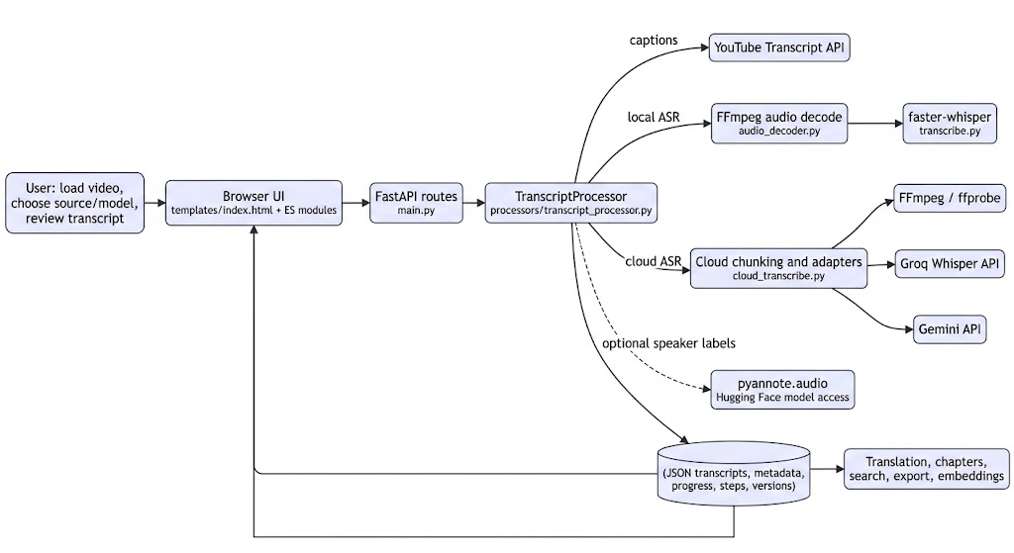

B. Generation sequence. The polling loop is browser-driven; the API schedules the work and returns status while the worker performs inference.

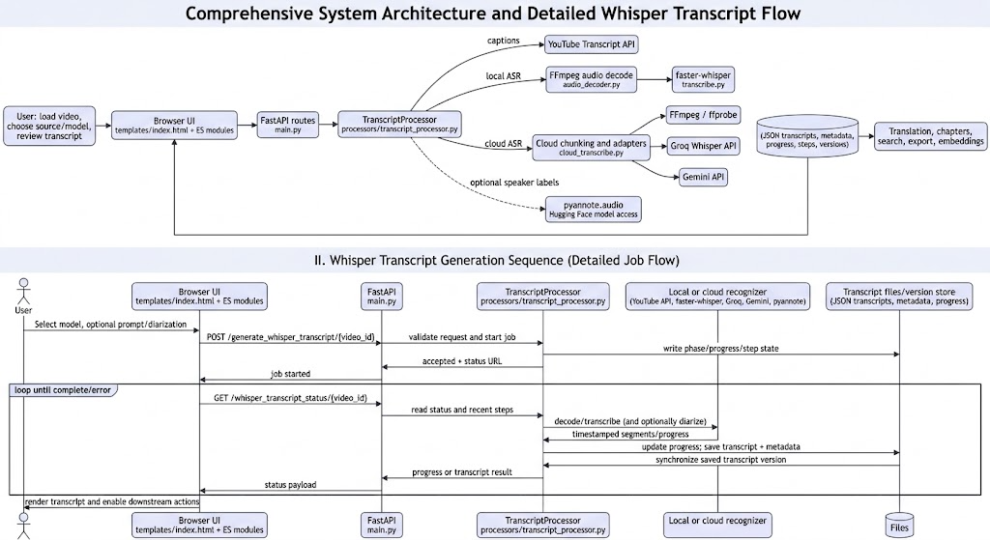

C. Job state model. The file-backed phase markers and API status payloads represent the following lifecycle; queued and terminal states are response states, while active phases are persisted during work.

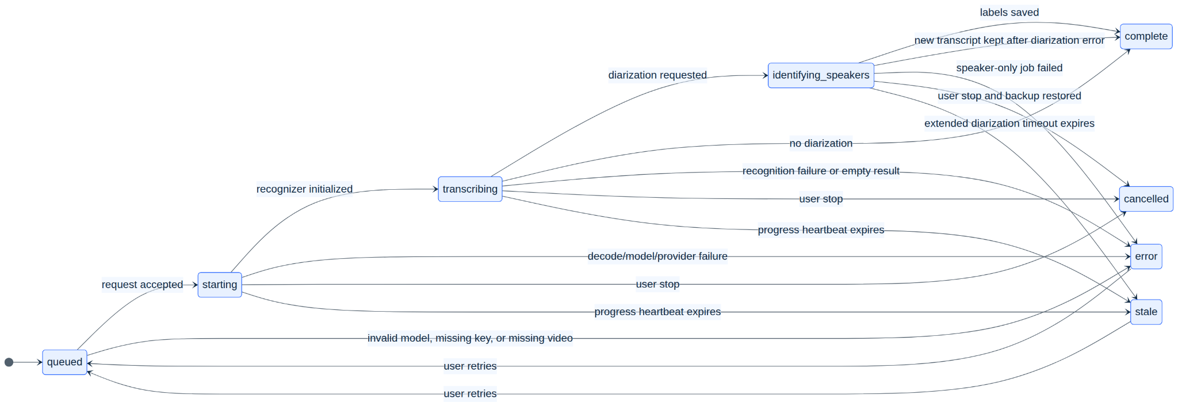

D. Logical transcript data relationship model. This is a logical view of the JSON persistence, not a claim that the project uses a relational database or that these are Python classes.

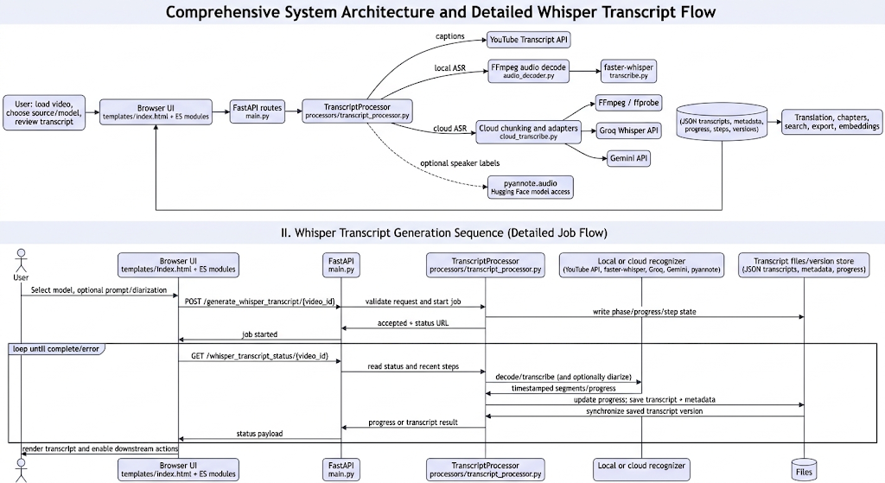

D2. Source-level class diagram. TranscriptProcessor is the central application class. The ASR adapters and version store are module-level functions/modules; they are shown with <<module>> stereotypes rather than being misrepresented as instantiated application classes. Whisper and pyannote types are external library classes.

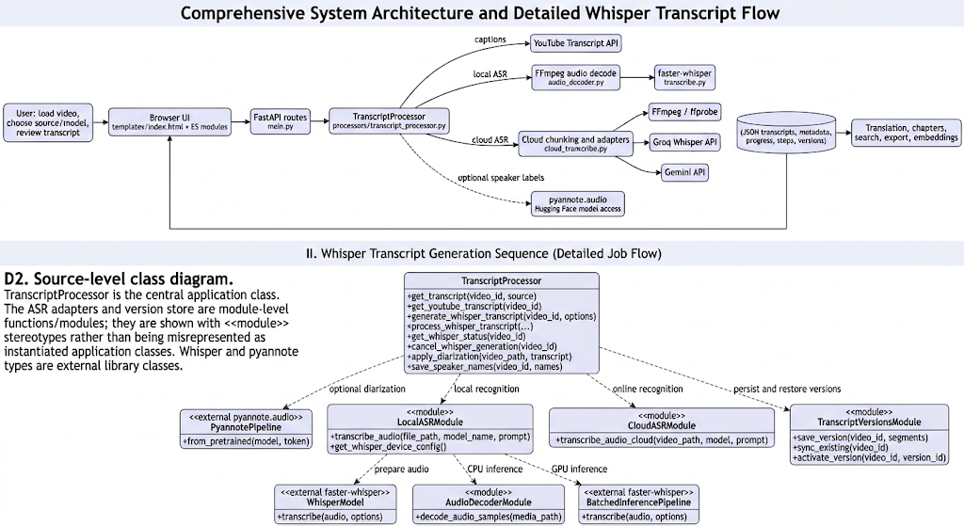

E. Suggested transcript review-screen template. The existing template has equivalent core controls. This logical wireframe emphasizes the speech workflow and should not be read as an implemented new screen.

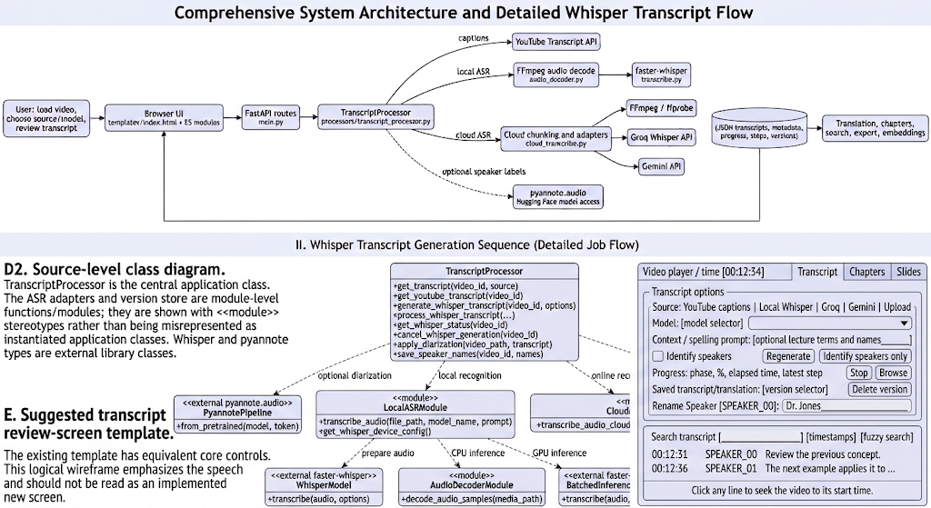

4.1 Diagram coverage and additional diagrams
This subsection checks the report against the 18 diagram types in the professional-report checklist. Diagrams describe the observed speech/transcription subsystem, except where explicitly marked as a proposed logical view. The codebase is not a database-backed service, has no observed automated CI/CD workflow, and does not implement the internals of the hosted ASR models; diagrams do not imply otherwise.

F. System context diagram. The boundary view identifies the user, the application, its media inputs, and third-party services. In particular, local ASR keeps audio on the application host, while cloud ASR sends extracted audio to the selected provider.

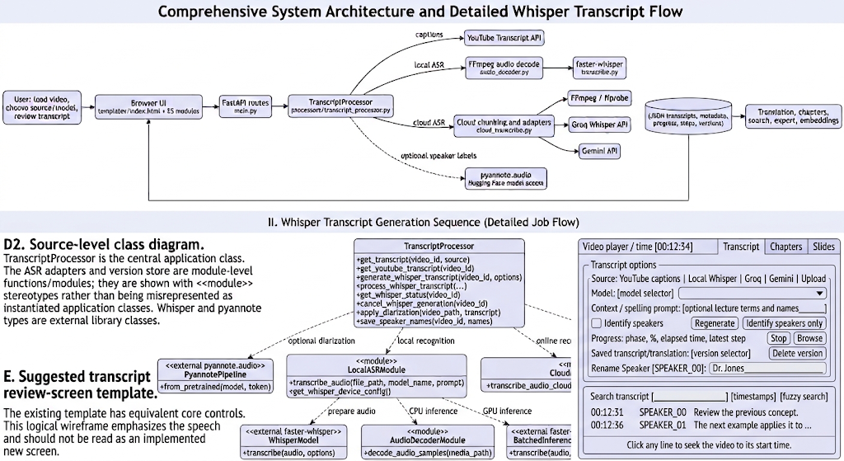

G. Use case diagram. The labels distinguish what the learner can request from optional operator configuration; provider services are external actors. The Mermaid flowchart notation is used to keep this use-case view renderable across Mermaid versions.

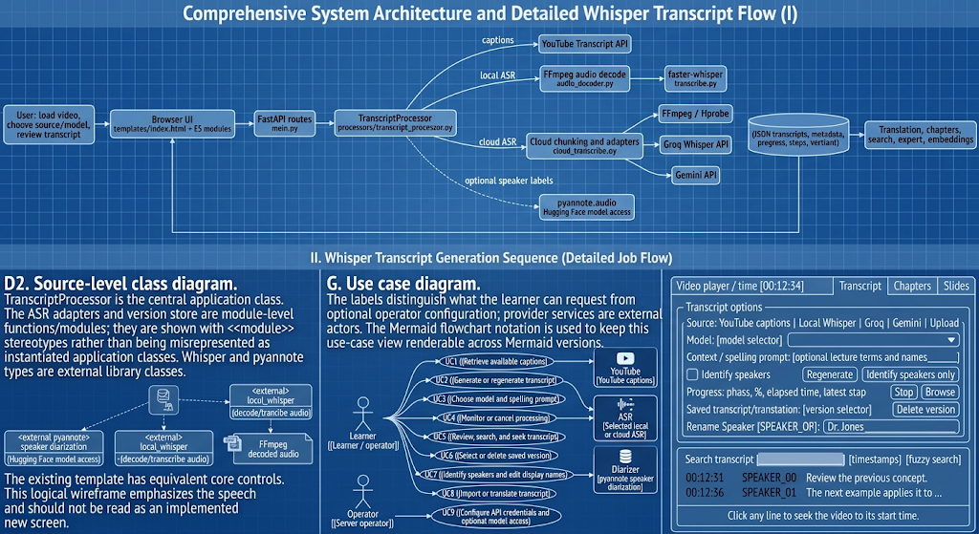

H. System architecture diagram. This logical layering summarizes the current implementation: browser, FastAPI orchestration, recognizer adapters, and file-backed persistence. It is a single application, not a set of independently deployed microservices.

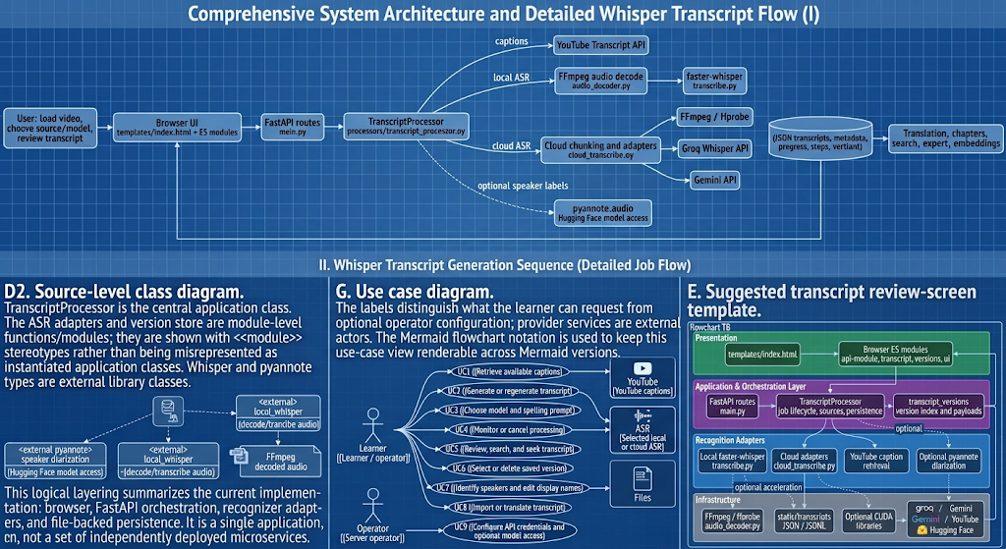

I. Activity diagram. The decision paths reflect source selection, optional diarization, terminal failures, and version saving.

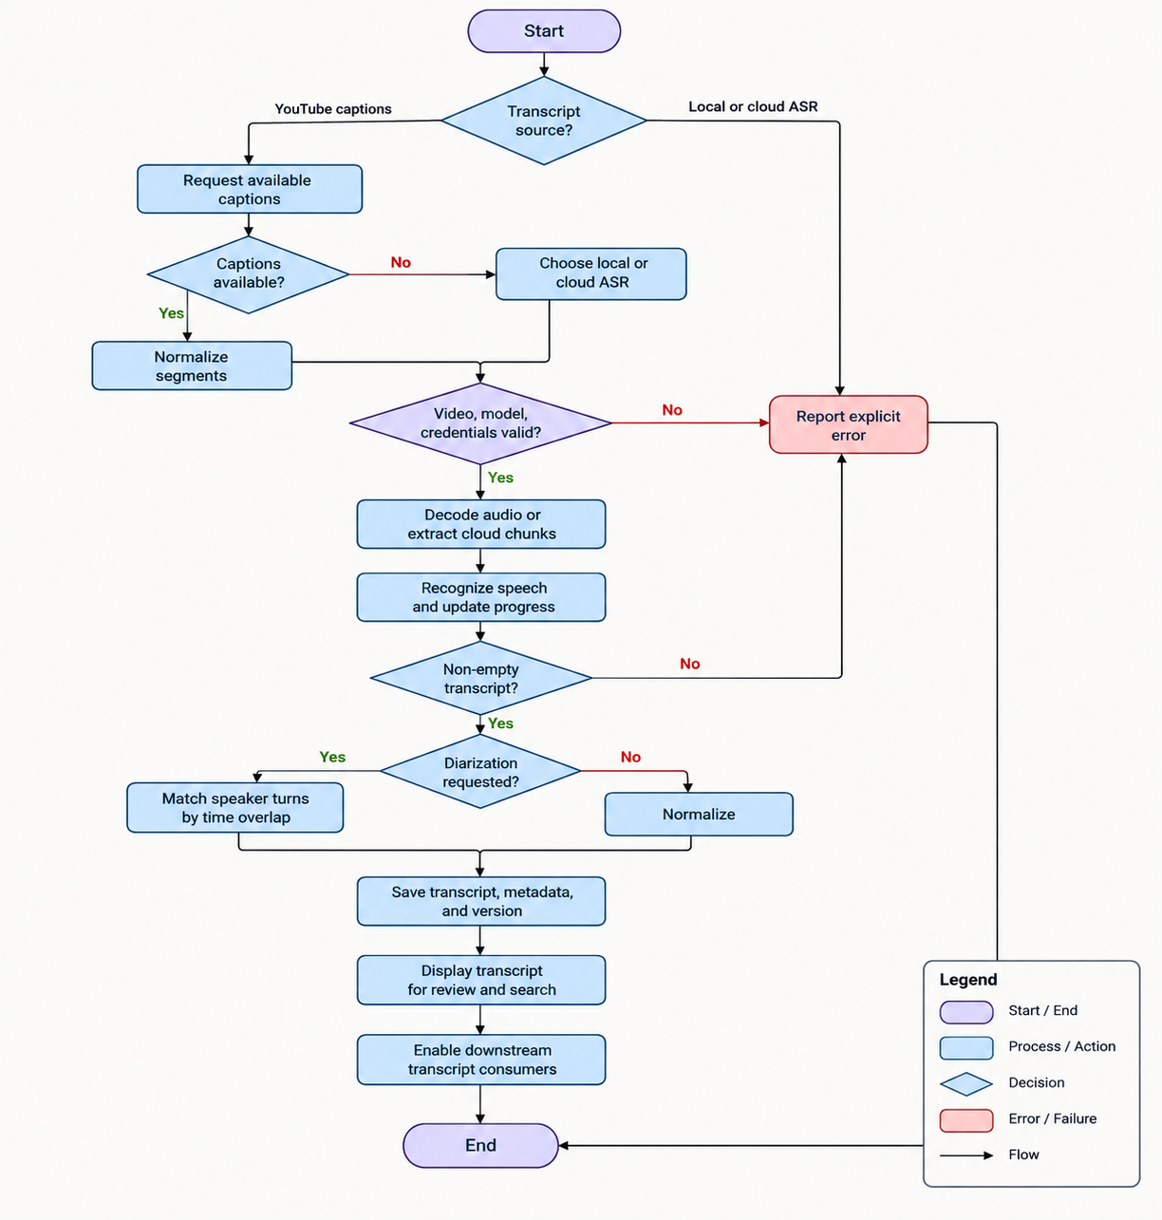

J. Entity-relationship diagram (logical file-backed ERD). The diagram models relationships represented in transcript and version JSON files. It is not a physical database schema: no relational database is used for this feature.

K. Data-flow diagram (DFD). Level 1 makes audio, transcript and progress flows visible separately. The transcript file store is a set of local JSON/text files, not an external database.

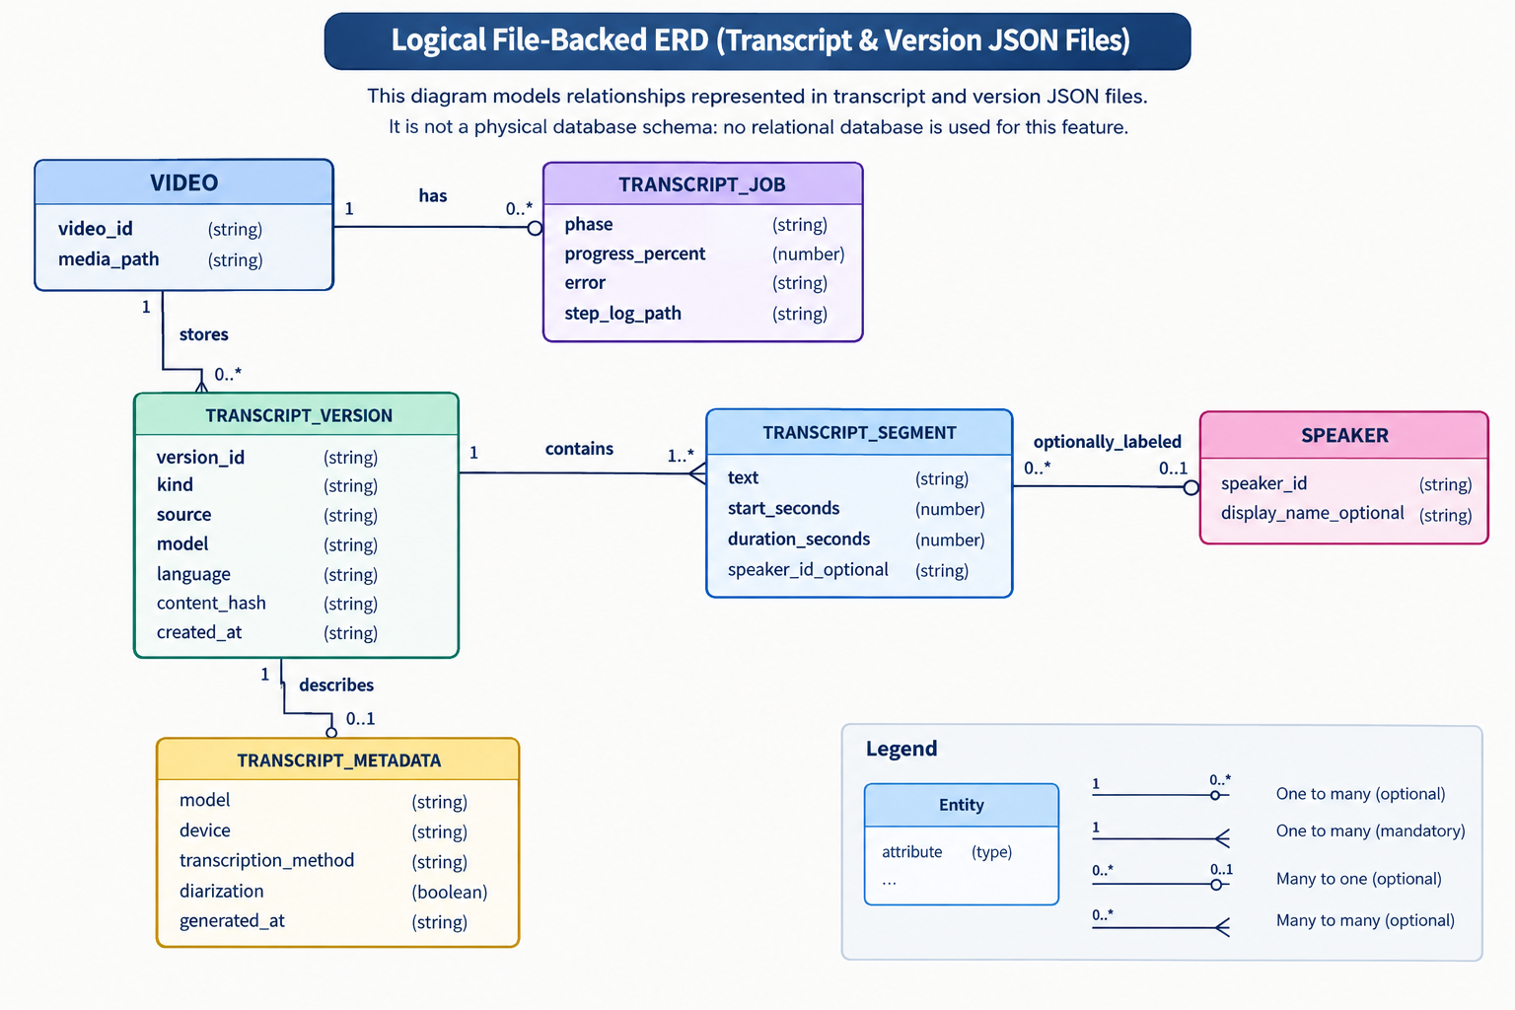

L. Data-processing pipeline diagram. This is the implementation-oriented signal path; cloud chunking and local full-audio decode are intentionally separate branches.

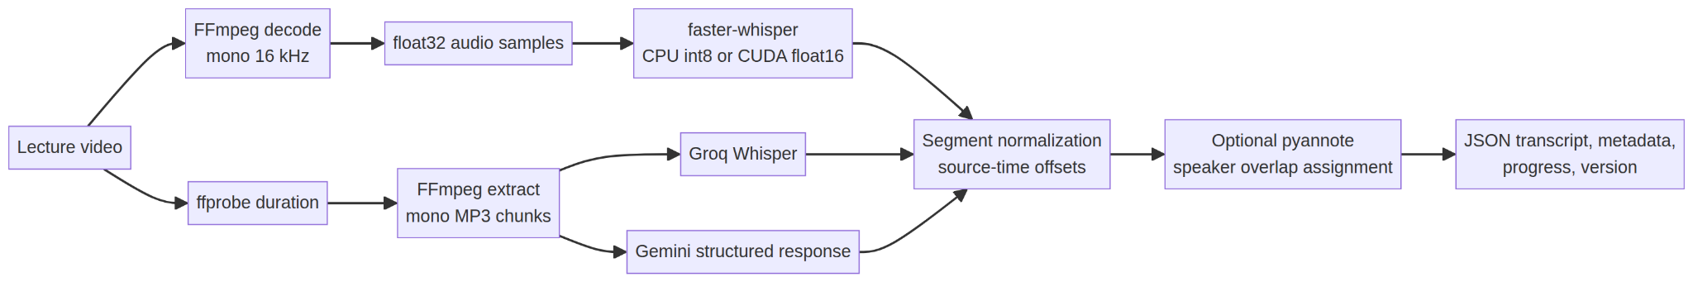

M. Deployment diagram. This is the current supported logical topology: the FastAPI server and local files share one host; GPUs and external APIs are optional. No separate database or durable queue is present. The code's __main__ development entry point binds to 0.0.0.0:8000; do not interpret that as safe public deployment.

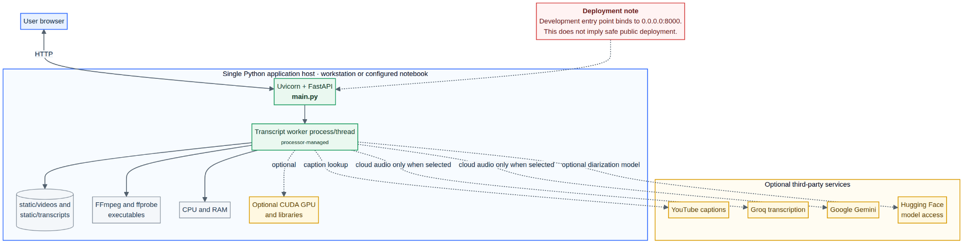

N. API / system integration diagram. It shows actual route families and external dependencies without implying that each route is a separate service.

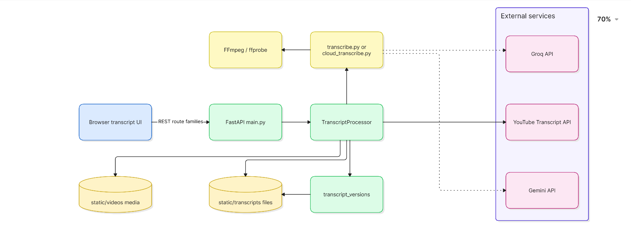

O. Algorithm flowchart. This captures the recognition branch from request validation through chunk processing and source-time restoration.

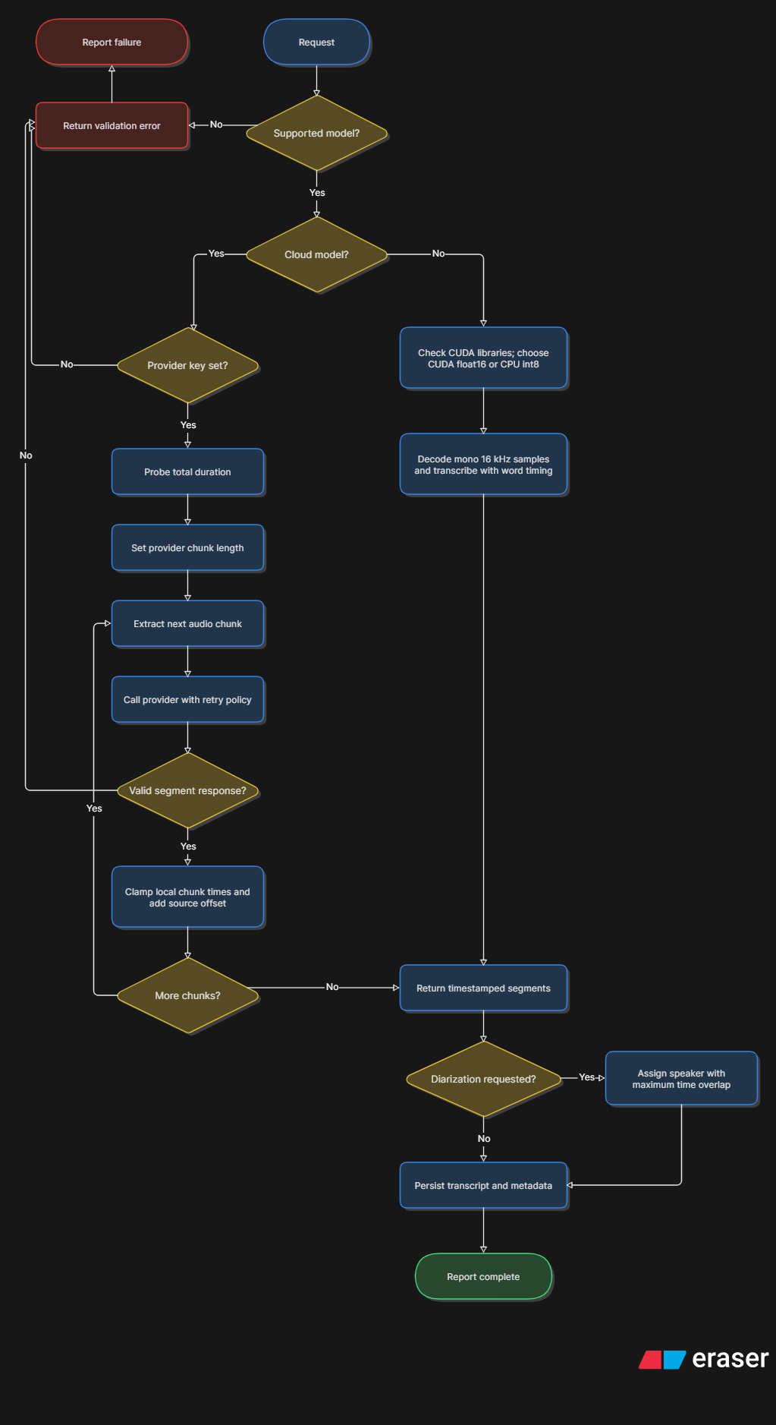

P. AI/ML model architecture diagram. The local model's internal neural-network layers and hosted providers' model internals are not implemented in this repository. This diagram therefore documents the application's actual inference architecture and its boundary, not a fabricated neural-network layer diagram.

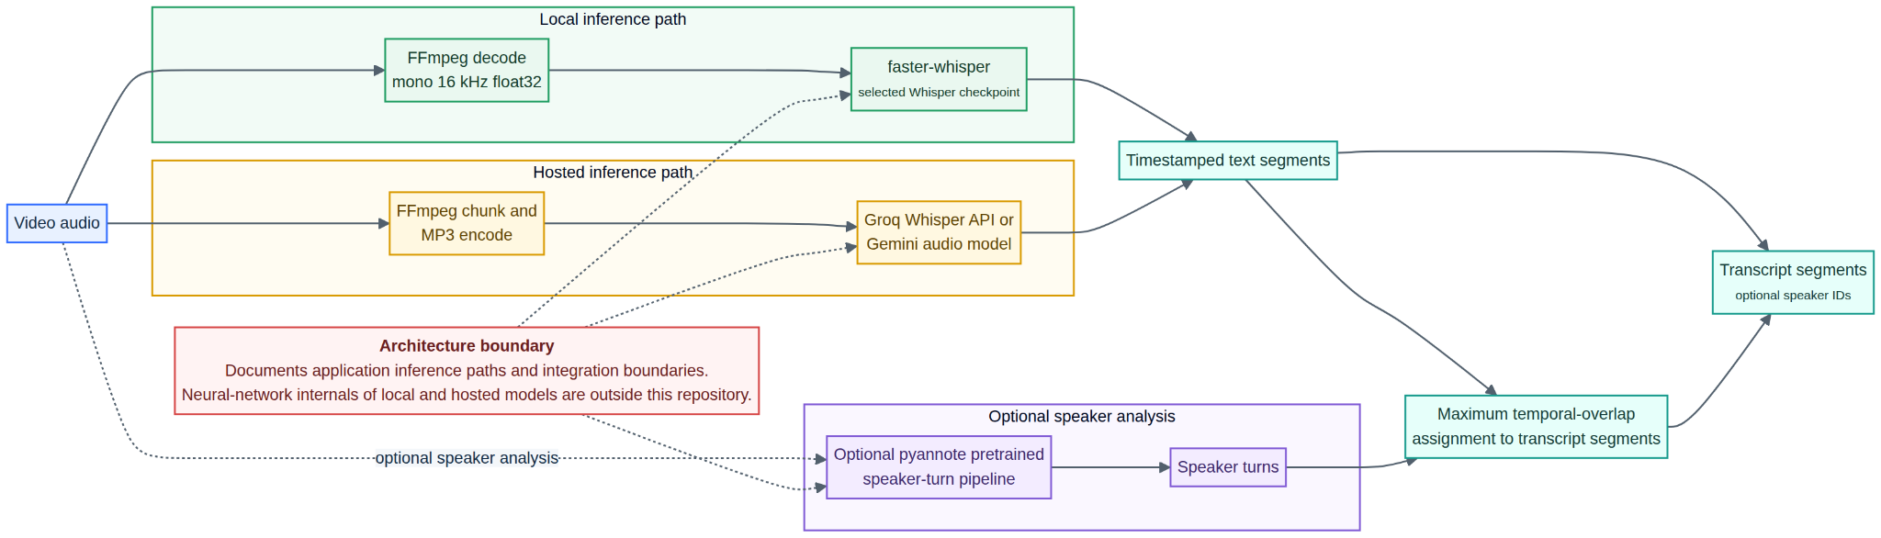

Q. Testing architecture diagram. Test levels identify the actual regression coverage and the currently missing real-model accuracy acceptance benchmark.

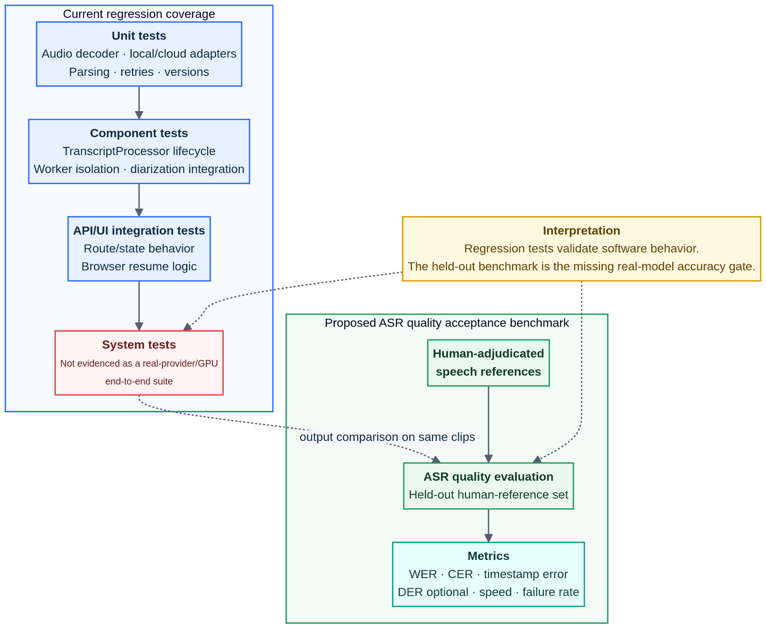

R. Security / threat-model diagram. The relevant trust boundaries are external audio processing, credentials, browser-provided parameters and file-backed storage. This is a threat-analysis view, not evidence that the application currently implements all mitigations.

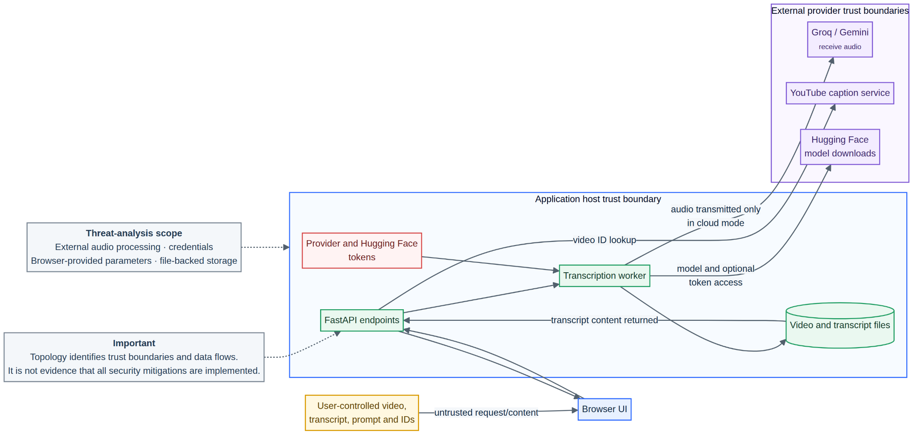

Threats to review include unintended cloud disclosure of lecture audio, API-key exposure, unsafe or oversized uploads, path/ID misuse against file storage, injection of transcript text into the browser, abuse of unauthenticated routes if network-exposed, and denial of service through long media or concurrent model jobs. The project report elsewhere notes that the app has no visible authentication layer; the server's 0.0.0.0 development binding should therefore be restricted by deployment controls. Assess and implement mitigations before deployment beyond a trusted local environment.

Checklist status for all 18 diagram types

# | Requested diagram | Status in this report | Notes
1 | System Context Diagram | Included (F) | Shows user, application boundary, input video and external services.
2 | Use Case Diagram | Included (G) | Learner/operator interactions, caption service, ASR and diarization.
3 | System Architecture Diagram | Included (H) | Current layered single-application structure.
4 | Component Diagram | Included (A) | Existing software components and dependencies.
5 | Activity Diagram | Included (I) | Source selection, recognition, diarization and persistence decisions.
6 | Sequence Diagram | Included (B) | Browser polling and worker interaction.
7 | Class Diagram | Included (D2) | Shows the actual application class, module-level adapters and external model classes.
8 | Entity Relationship Diagram (ERD) | Included (J), logical | File-backed logical entities only; the project has no relational database for this subsystem.
9 | Data Flow Diagram (DFD) | Included (K) | Level-1 speech data movement.
10 | Data Processing Pipeline Diagram | Included (L) | Local/cloud preparation and recognition branches.
11 | Deployment Diagram | Included (M), logical | Current single-host and external-provider topology; deployment configuration can vary.
12 | API / System Integration Diagram | Included (N) | Actual API route families and service integrations.
13 | State Machine Diagram | Included (C) | Current job lifecycle and recovery states.
14 | Algorithm Flowchart / Pseudocode | Included (O) | Current model selection, chunking and timestamp flow.
15 | AI/ML Model Architecture Diagram | Included (P), boundary-level | Application inference architecture; model internals are external/opaque.
16 | Testing Architecture Diagram | Included (Q) | Existing regression levels and proposed quality-acceptance layer.
17 | CI/CD Pipeline Diagram | Not applicable to current implementation | No .github/workflows files or automated deployment pipeline were found in this project tree. A proposed pipeline is intentionally not presented as implemented.
18 | Security / Threat Model Diagram | Included (R), analysis | Trust boundaries and principal risks; it is not a claim that mitigations are complete.

5. API and file templates
Generation request template (fields are optional unless indicated by the action):

{

"model": "turbo",

"prompt": "Domain terms, names, acronyms, or spelling guidance",

"diarization": false,

"force": true,

"speakers_only": false

}

The model identifier must be one listed by the backend. speakers_only: true requires a saved Whisper transcript and reuses its transcript text; it implies diarization. A successful start returns a success/message/phase and a status URL; missing video, unsupported model, or unconfigured cloud credentials are reported as errors.

Status response templates (illustrative shape; optional fields differ by phase):

{"success": true, "status": "in_progress", "progress": 42.0,

"phase": "transcribing", "steps": [{"elapsed": 5.2, "message": "Transcribing..."}],

"steps_elapsed": 7.1}

{"success": true, "status": "complete", "model": "turbo",

"transcript": [{"text": "A sentence.", "start": 12.345, "duration": 2.678}],

"speaker_names": {}, "metadata": {"device": "cuda"}}

{"success": false, "status": "error", "error": "Human-readable failure detail"}

Persistent artifact convention (per video_id, under static/transcripts/):

Artifact | Role
{video_id}_youtube.json | Cached formatted YouTube caption segments.
{video_id}_whisper.json | Current generated transcript segments (local or cloud model).
{video_id}_whisper_meta.json | Model/options/device/timing/diarization metadata and speaker display-name map.
{video_id}_whisper_progress.txt and {video_id}_whisper_phase.txt | File-backed status and current active phase.
{video_id}_whisper_steps.jsonl | Timestamped step messages used for progress diagnostics.
{video_id}_whisper_error.txt | Last recorded processing failure.
{video_id}_whisper_before_speakers.json | Temporary safety backup while an existing transcript is being relabeled.
versions/{video_id}/index.json and version JSON payloads | Deduplicated, selectable transcript/translation versions and associated metadata/chapters.

These are implementation conventions, not a versioned public storage schema. The report recommends adding explicit schema versions and atomic writes consistently before relying on these files for long-term interchange.

6. Source-file responsibility map
The first table lists files that implement or directly run speech recognition/transcript operations. The second lists adjacent files that connect the speech subsystem to the wider application; the latter are important integrations but are not themselves ASR engines.

Direct implementation and execution files

File | Responsibility in this feature
main.py | FastAPI route wiring for transcript retrieval, caption retrieval, transcript upload, model generation, status, cancellation, metadata, source preference, speaker-name updates and version operations. Also wires processors and app lifecycle.
processors/transcript_processor.py | Core orchestration: source formatting and YouTube caption retrieval; model/key validation; background task scheduling; local/cloud worker selection; progress, phase, stale detection, cancellation and recovery; metadata; optional pyannote diarization; speaker-name validation; source preference.
transcribe.py | Local faster-whisper: supported local model list, CUDA/native-library check and CPU fallback, model initialization, optional prompt, word timestamp extraction, sentence/SRT formatting and progress milestones.
cloud_transcribe.py | Groq/Gemini model configuration, provider credentials, hardware-aware default recommendation, duration/chunk handling, FFmpeg extraction, API requests, retry policy, Gemini schema/parser and global timestamp offsets.
audio_decoder.py | Converts a media file's audio track to mono 16 kHz float32 samples for local Whisper and speaker analysis; raises explicit errors for missing FFmpeg, invalid media or absent audio.
ffmpeg_tools.py | Finds/validates FFmpeg and ffprobe through PATH, configured executable variables and Windows installation paths.
project_paths.py | Defines transcript/video/runtime directories and directory initialization used by the transcript persistence layer.
processors/transcript_versions.py | Stores/deduplicates transcript and translation versions, active-source state, associated metadata/chapters, and speaker propagation to translated records.

UI and downstream integration files

File | Relationship to speech/transcription
templates/index.html | Defines transcript tab, model and prompt controls, optional diarization, speaker-name editor, import and translation controls, progress container, version selector, transcript search/timestamp controls and source preference settings.
static/js/api-module.js | Calls generation/status/cancel endpoints, polls and renders progress/errors, performs transcript import/translation, applies speaker names and reconnects to an active generation.
static/js/transcript.js | Normalizes incoming transcript arrays, renders timestamped/speaker-tagged lines, seeks video on selection, and updates the active line while playback moves.
static/js/transcript-versions.js | Lists, activates and deletes saved transcript/translation versions and keeps chapter language/source aligned.
static/js/ui.js | Settings modal, source/model preferences, controls and user notifications/errors.
static/js/main.js | Shared frontend state and app initialization; connects transcript UI actions to API and display modules.
static/js/elements.js | Central DOM-element references used by transcript/settings operations.
static/js/index.js | Browser entry point that starts the page/application.
static/js/search.js | Transcript search, fuzzy-search and timestamp display interactions.
static/js/chapters.js | Uses transcript text to request/render chapters and connect transcript-derived chapter boundaries to navigation/exports.
processors/video_processor.py | Starts transcript generation for new/reused saved videos where no generated transcript exists and restores the active transcript/translation on reload.
processors/summary_processor.py | Downstream use of active transcript segments for chapter generation and translation; not part of acoustic recognition.
processors/embedding_processor.py | Downstream use of transcript segments in transcript-to-OCR semantic matching; not part of acoustic recognition.
requirements.txt | Declares FastAPI, NumPy, faster-whisper, provider SDKs, av compatibility pin and pyannote.audio among the project's Python dependencies. FFmpeg binaries, provider keys and Hugging Face access are separately configured.

The exact user-visible sources and options are defined by both the backend model registry and the template selector; those lists should be kept synchronized. For example, the backend currently defines Gemini 2.5 Flash, while the current UI selector exposes Gemini 3.8 and 3.6 Flash.

7. Technologies used for this subsystem
Technology | Role and design reason
faster-whisper / CTranslate2 | Local Whisper inference; offers model-size choices and efficient CPU/GPU execution.
PyTorch CUDA availability probe | Checks whether CUDA is visible; transcribe.py additionally attempts to load required native CUDA/cuDNN libraries before selecting the GPU path.
FFmpeg / ffprobe | Audio decode/resample for local inference; cloud chunk extraction and media duration probing. Installed as system executables or selected via FFMPEG_BINARY / FFPROBE_BINARY.
NumPy | Represents decoded audio as a float32 sample array.
Groq Whisper API + OpenAI Python client | Cloud-hosted Whisper transcription through an OpenAI-compatible client; GROQ_API_KEY is supplied through the server environment.
Google Gemini API (google-genai) | Cloud audio transcription with structured JSON segment output; GOOGLE_API_KEY is supplied through the server environment.
YouTube Transcript API | Retrieves existing platform captions when the YouTube-caption path is requested.
pyannote.audio + Hugging Face Hub | Optional speaker diarization pipeline, using a configured or saved access token and accepted pretrained-model terms.
FastAPI / Starlette background task facilities | Expose HTTP operations and schedule background transcript work while the application continues serving requests. Status is currently file-backed, not a durable distributed job queue.
JSON / JSONL files and Python threading/process primitives | Persist transcript, metadata, phase, progress and diagnostic step data; support current worker isolation and heartbeat/recovery behavior.
Browser ES modules, HTML and CSS | Provide controls, asynchronous polling, transcript presentation, version selection, speaker-name editing and video synchronization without a frontend framework.

8. Speech/transcription software requirements specification
This is a scoped SRS for the transcript feature, derived from the checked-out implementation plus explicitly labeled recommended criteria. It does not specify the entire lecture-analysis application.

Actors and assumptions

- A learner/operator loads a local or YouTube video and can select a transcript source/model.
- The local service can access the video file and its persistent transcript directory.
- Local ASR requires compatible Python packages and FFmpeg. GPU acceleration is optional.
- Cloud ASR requires an applicable provider key, Internet connectivity, provider availability and user approval to transmit audio.
- Diarization is optional and requires pyannote dependencies, Hugging Face credentials/access and the applicable model terms.
- Source media is expected to contain a decodable audio track; silent/no-audio recordings should produce a clear failure, not a fabricated transcript.

Functional requirements

ID | Requirement
SR-FR-01 | The system shall retrieve available YouTube captions for supported configured languages and normalize caption text and start/duration fields.
SR-FR-02 | The system shall transcribe a saved video using a validated local Whisper model or configured supported cloud model.
SR-FR-03 | The system shall accept an optional user prompt for vocabulary, names and spelling without instructing the recognizer to invent or summarize speech.
SR-FR-04 | The system shall convert supported transcript imports into the common segment representation and make them available as a transcript source.
SR-FR-05 | Each persisted transcript segment shall contain text and a non-negative source-video start time; duration shall be non-negative when present. Speaker ID/display name shall be optional.
SR-FR-06 | The system shall return useful job state, progress, processing phase and recent diagnostic steps for an active recognition job, and expose terminal success or failure.
SR-FR-07 | The user shall be able to request regeneration, cancel an active job and select among saved transcript versions without silently replacing unrelated versions.
SR-FR-08 | The system shall persist model/source metadata sufficient to identify how an ASR transcript was generated; provider keys shall never be persisted with transcript metadata.
SR-FR-09 | If requested, the system shall associate diarized speaker turns to transcript segments by temporal overlap and allow editing of display names without changing recognized wording.
SR-FR-10 | Transcript lines shall remain synchronized with video playback; selecting a line shall seek to its start time, and search shall operate over displayed transcript text.
SR-FR-11 | The transcript shall be usable by the existing chapter/translation, export and transcript-to-slide downstream paths.
SR-FR-12 | Cloud-provider failure, missing credentials, unsupported model, undecodable media, empty-speech results and stale jobs shall be surfaced as explicit errors or retryable states.
SR-FR-13 | Evaluation reports shall show English, Arabic and mixed Arabic-English results separately when those strata are in scope; captions not requested/supported for a language shall be marked unavailable rather than scored as an ASR failure.

Non-functional requirements and proposed acceptance criteria

ID | Quality attribute | Proposed measurable criterion
SR-NFR-01 | Accuracy | On the agreed held-out English clear-speech benchmark, proposed macro WER target: <= 15% after documented normalization. Publish strict results and per-clip results too. This is a proposed target, not an achieved measurement.
SR-NFR-02 | Timing | For sources reporting timestamps, report absolute segment-start/end error against human references; proposed target median <= 0.5 s and 90th percentile <= 1.5 s. Report local word timing separately from cloud sentence/segment timing.
SR-NFR-03 | Responsiveness | Report real-time factor and time-to-first-segment separately for each model, device and media duration. Set deployment-specific thresholds only after the hardware/provider environment is fixed.
SR-NFR-04 | Reliability | In repeated mocked and integration runs, successful jobs shall yield a non-empty valid segment array; failure shall not be represented as success. Test cancellation, retry, stale status and previous-transcript restoration.
SR-NFR-05 | Compatibility | Run targeted tests on supported OS/Python/CPU configurations and separately validate optional CUDA and cloud credentials; clearly identify untested combinations.
SR-NFR-06 | Privacy | Keep local-mode audio local; show explicit notice/choice before cloud transmission in deployments that expose cloud providers. Do not log API keys or unnecessary raw transcript/audio content.
SR-NFR-07 | Persistence | Metadata and transcript must correspond to the same completed job. Writes should be atomic and schema-versioned before production or concurrent multi-worker use.
SR-NFR-08 | Accessibility/usability | Controls have labels, keyboard operation and understandable progress/error messages; transcript text is selectable/searchable and line activation seeks accurately.
SR-NFR-09 | Resource use | Establish measured memory, CPU/GPU and disk envelopes across target durations; reject or constrain inputs that exceed documented limits rather than exhausting host resources.
SR-NFR-10 | Language coverage | Report WER and CER separately for English, Arabic and mixed Arabic-English, with the normalization/tokenization policy and relevant dialect/accent stated. Set Arabic/mixed acceptance thresholds after the initial pilot establishes a reviewed baseline; do not hide poor strata in an aggregate.

Interface and API specification

Operation | Existing route | Scope
Read a source transcript | GET /get_transcript/{video_id}/{source} | Reads/fetches supported source, formatted response and transcript metadata where applicable.
Generate/regenerate | POST /generate_whisper_transcript/{video_id} | Starts background work using model/prompt/diarization/force/speakers-only options.
Poll job | GET /whisper_transcript_status/{video_id} | Returns queued, in-progress, complete or error state with progress/steps/metadata as available.
Cancel job | POST /cancel_whisper_transcript/{video_id} | Stops active worker and restores a backup when relevant.
Read model metadata | GET /transcript_metadata/{video_id} | Returns public ASR metadata (not provider secrets).
Set/get source preference | POST /set_transcript_preference, GET /get_transcript_preference | Changes/reads the application-level YouTube/Whisper preference.
Update speaker display names | POST /speaker_names/{video_id} | Persists names for speakers present in the saved transcript.
Manage versions | GET /transcript_versions/{video_id}, POST /transcript_versions/{video_id}/{version_id}/activate, DELETE /transcript_versions/{video_id}/{version_id} | Lists/selects/deletes persisted transcript or translation versions.
Import/translate transcript | POST /upload_transcript/{video_id}, POST /translate_transcript/{video_id} | Adjacent text-source operations; translation is not speech recognition.

9. Proposed transcription evaluation method
Objective. Compare the caption, local and cloud approaches on transcription accuracy, timing, throughput, reliability and operational cost/privacy without claiming an unmeasured winner. A single overall WER is insufficient because the sources differ in language coverage, timing granularity, hardware and data-handling model.

Small, feasible pilot (first evaluation milestone)
To inform the initial-version choice promptly, run this bounded pilot before expanding to the full benchmark:

- Select three 3–5 minute lecture excerpts (9–15 minutes total) that the team has permission to use. Record the source, excerpt offsets, checksum, language and consent/licensing basis.
  - Excerpt A — English: clear university speech with several course-specific terms, acronyms or proper names.
  - Excerpt B — Arabic: an Arabic-language lecture. Record whether it is Modern Standard Arabic, a named dialect, or a mixture; note the accent where known.
  - Excerpt C — code-switch: Arabic and English used in the same lecture, including technical terms.
  - Difficult-audio coverage: ensure at least one evaluated excerpt contains naturally noisy audio and at least one contains multiple speakers or overlapping speech. Excerpt C may cover either or both; if it does not cover both, add one or two short excerpts. Record accents for every clip and include more than one accent where the source material allows.
- Prepare references before model runs. Two annotators fluent in the relevant language(s) independently transcribe verbatim, preserving code-switches and technical terms. Adjudicate disagreements and mark unintelligible spans. One annotator labels utterance/segment start and end times; a second checks all boundaries or a representative sample. Keep references out of model prompts.
- Run three candidates on identical excerpts: local faster-whisper large-v3; Groq Whisper Large v3 if cloud processing is approved and a key is available; and YouTube captions only when available. The current application requests English and French captions, so mark this source as not supported by the current integration for Arabic rather than scoring its absence as an ASR failure. Optionally run local turbo as a speed/resource comparison. Defer Gemini unless results reveal a specific reason to evaluate it.
- Control the comparison. First run without a prompt. If time permits, repeat local/Groq with the same compact glossary (for example, under 700 characters) containing course terms and accepted spellings; record prompted and unprompted results separately. Use identical excerpt boundaries, record model IDs/date, detected language, hardware, FFmpeg version, retries, runtimes, failures and timestamp source. Do not translate output before scoring.
- Score by excerpt and language. Report text accuracy, technical-term errors, utterance-boundary timing, completion time/real-time factor, failures, hardware, and whether audio left the host. Record provider pricing and quota with a date and account basis; do not assume free-tier access is permanent.
- Apply the decision rule. Retain local large-v3 as primary if it meets agreed accuracy and timing limits for each required language and runs within the target host's resource/time budget. Otherwise select the passing candidate with the best measured balance. Any hosted method must remain explicit opt-in with an audio-transmission notice. Use captions as primary only where suitable captions exist for the video's language and independently pass quality criteria.

Scoring protocol for Arabic and code-switching
- WER is (S + D + I) / N, where substitutions, deletions and insertions are counted against human-reference words. Report the counts, reference word count and normalization policy.
- Publish two text scores: strict (Unicode normalization, declared punctuation/case policy and consistent whitespace) and language-normalized. For Arabic, the normalized view may remove diacritics and tatweel, standardize Arabic punctuation/spacing, and map alef forms أ, إ, آ to ا. Apply rules identically to reference and hypothesis and report how strict and normalized scores differ.
- Do not silently erase lexical distinctions. Keep ة/ه, ى/ي, dialect forms, clitic attachment, transliterations and technical spelling differences in the primary normalized score. If the team collapses any of these for a secondary analysis, label it explicitly and publish the strict score too.
- For Arabic-English clips, preserve the language actually spoken; never translate or transliterate output to simplify scoring. Apply documented tokenization to Arabic-script and Latin-script text. Report mixed-clip WER and, where code-switch boundaries are reliably annotated, separate Arabic-span and English-span WER. If segmentation makes word counts unstable, add CER and document tokenization.
- Measure technical-vocabulary performance separately using a glossary frozen before transcription. Report term occurrences and substitutions/deletions/insertions for acronyms, product names and course terms so lecture-critical errors are not hidden by aggregate WER.
- Timestamp quality: persisted local and cloud outputs are sentence/phrase segments, and the cloud integration does not return word-level timing. Match hypothesis/reference utterances using a documented text-alignment method and report absolute start/end errors in seconds, median, P90 and percentages within ±0.5 s and ±1.0 s. Manually inspect unmatched spans. Do not call this word-level accuracy. If word-level quality is required, use an evaluation-only harness to capture local Whisper word timings before sentence aggregation and report separately from product output.
- Report each excerpt and a macro-average. Three short clips are useful for a pilot and failure discovery, not a general statistical superiority claim; expand to the stratified benchmark before broad quality claims.

Pilot result sheet and status
No reference lecture excerpts, annotated timestamps or completed live model/provider runs were available in the evidence reviewed for this report. Therefore no measured sample results are reported. Not run below is intentional and must only be replaced with observed values after executing the test.

Excerpt / condition | Method and exact model ID | Strict WER | Normalized WER | CER | Technical-term errors | Median / P90 segment boundary error (s) | Runtime / RTF | Cost per audio hour | Failure / retry | Notes
A — English, clear, technical terms | Local faster-whisper large-v3 | Not run | Not run | Not run | Not run | Not run | Not run | Local compute cost not measured | Not run | Candidate primary
A — English, clear, technical terms | Groq Whisper Large v3 | Not run | Not run | Not run | Not run | Not run | Not run | Record current account price/quota | Not run | Hosted opt-in
A — English, if available | YouTube captions | Not run | Not run | Not run | Not run | Not run | Not run | No ASR call by this app | Not run | Baseline only; not gold truth
B — Arabic lecture | Local faster-whisper large-v3 | Not run | Not run | Not run | Not run | Not run | Not run | Local compute cost not measured | Not run | Record MSA/dialect and accent
B — Arabic lecture | Groq Whisper Large v3 | Not run | Not run | Not run | Not run | Not run | Not run | Record current account price/quota | Not run | Confirm current API model support
B — Arabic lecture | YouTube captions | N/A | N/A | N/A | N/A | N/A | N/A | N/A | N/A | Current integration requests only English/French
C — Arabic-English code-switch | Local faster-whisper large-v3 | Not run | Not run | Not run | Not run | Not run | Not run | Local compute cost not measured | Not run | Record noise/speaker conditions
C — Arabic-English code-switch | Groq Whisper Large v3 | Not run | Not run | Not run | Not run | Not run | Not run | Record current account price/quota | Not run | Record noise/speaker conditions
D — noisy and/or multi-speaker excerpt, if needed | Local faster-whisper large-v3 | Not run | Not run | Not run | Not run | Not run | Not run | Local compute cost not measured | Not run | Label noise/overlap/accent condition
D — noisy and/or multi-speaker excerpt, if needed | Groq Whisper Large v3 | Not run | Not run | Not run | Not run | Not run | Not run | Record current account price/quota | Not run | Label noise/overlap/accent condition

For each row, record host/GPU, language-detection output, prompt condition, audio-transmission status and dated pricing/quota evidence. If a run cannot be performed (for example, no API key or no Arabic caption), record why; do not enter zero error or infer a result.

Pilot decision record template

Decision date:

Reference clips and consent/licensing:

Scoring normalization/version:

Target hardware:

Required language strata:

Accuracy and timestamp acceptance limits:

Primary method selected:

Evidence supporting selection (paired clip results):

Known failure modes and limitations:

Cloud fallback enabled? (yes/no; consent and pricing basis):

Conditions that trigger re-evaluation:

Approvers:

1. Construct a representative gold set.

- After the pilot, collect at least 20 hours of lecture audio or a statistically justified equivalent set of clips, stratified by English and Arabic (including relevant dialects), mixed Arabic-English code-switching, speaker accent, recording quality, room noise/reverberation, speaking rate, topic/technical vocabulary, single/multiple speakers and slide/video audio quality. State exclusions and licensing/consent.
- Split by lecturer/course (not by adjacent clips from the same recording) into development and held-out test partitions to reduce leakage. Freeze the test set before comparing candidate configurations.
- Create verbatim reference transcripts with two independent annotators on a shared transcription convention, followed by adjudication. Record unintelligible spans, disfluencies, punctuation/casing conventions, Arabic normalization policy, language switches and technical-term spelling rules. Keep the reference text separate from the optional prompts supplied to the models.
- Annotate word or segment onset/offset times for a stratified subset, and speaker turns if diarization is being evaluated. At least a sample should receive a second timestamp/diarization review.
- Where YouTube captions exist, preserve them as a separate baseline. Do not treat platform captions as gold truth; human-adjudicated references are the gold standard.

2. Freeze the experiment. Record video/audio hashes, clip boundaries, model/API identifier and date, faster-whisper version, decoding configuration, hardware, FFmpeg version, language/prompt settings, chunk rules, provider retry behavior and every run's status. Use identical audio and decoding policy where technically possible. Do not give one candidate an unrecorded prompt or different reference information. Repeat stochastic/remote runs when service behavior may vary.

3. Calculate metrics.

- Word Error Rate (WER): (substitutions + deletions + insertions) / number of reference words. Publish strict/raw and explicitly language-normalized scores. Arabic WER is sensitive to clitic segmentation, diacritics, tatweel, alef variants and orthographic convention; freeze and publish normalization before testing. Do not equate normalization changes with recognition improvement.
- Character Error Rate (CER): the same edit-distance ratio at character level, useful alongside WER where Arabic segmentation and code-switching make whitespace tokenization unstable. Use language-aware normalization and never score translated output against a reference in the spoken language.
- Timestamp quality: for aligned words/segments, compute absolute start and end error in seconds, median, 90th percentile, and percentage within ±0.5 s / ±1.0 s. Match hypothesis/reference text spans using documented alignment; compare word-level and segment-level outputs separately. Cloud Gemini's approximate timestamps must not be compared as if they were word timings.
- Diarization (optional): report diarization error rate (DER) with the collar and overlap policy stated, speaker-attributed word error rate where feasible, and mapping between anonymous speaker IDs. Never report real-world identity accuracy from anonymous diarization.
- Efficiency: real-time factor processing seconds / audio seconds, wall-clock time-to-first-segment, total completion time, throughput, peak RAM/VRAM and failures/retries. Report warm and cold model runs separately.
- Operational trade-offs: cloud cost per audio hour and request counts (when provider pricing data is available), audio-transmission/privacy classification, required hardware/keys, and quota/rate-limit failure rate. Make pricing date and assumptions explicit.
- Uncertainty and fairness: report micro and per-clip macro results with bootstrap 95% confidence intervals; publish each stratification rather than only an aggregate. Compare paired results on the same clips and report worst/low-resource strata, not just averages.

4. Analyze and select. Use paired bootstrap confidence intervals for the WER/CER difference per clip; inspect statistically and practically meaningful gains alongside timing, speed, privacy and failure rate. Choose a primary method by deployment profile, with at least one fallback; specify whether fallback is automatic or user-controlled. Store the benchmark protocol, references, scoring scripts and anonymized aggregate outputs with the project evaluation artifacts (not in runtime transcript storage).

5. Recommended release gates (to be agreed and calibrated).

Gate | Proposed check
Content quality | Meet SR-NFR-01 on the held-out English clear-speech stratum; establish and document Arabic/mixed-language thresholds through SR-NFR-10 after the pilot. Publish strict/normalized WER, CER and domain-term errors.
Timing | Meet SR-NFR-02 on the annotated subset and state timestamp granularity limitations per provider.
Robustness | No silent-success/empty transcript on test failures; retries and error states are reported, and prior transcript is preserved during cancellation/speaker-only failure.
Language/accent | No major stratum regression hidden by aggregate metrics; evaluate languages separately, including accents and technical vocabulary.
Operational fit | Meet deployment-specific completion/resource/cost limits using the intended device and provider configuration; publish the environment and test date.

Current test evidence and sample-result status. tests/test_transcribe.py verifies model selection, prompt passing, CPU VAD/GPU batch options, timestamp-to-SRT conversion and invalid model rejection. tests/test_cloud_transcribe.py verifies provider selection, Gemini schema/parsing/retry, chunk offsets/progress, missing-key handling and rate-limit retries. tests/test_audio_decoder.py covers mono sample decoding and representative failure cases. tests/test_transcript_processor.py covers lifecycle/recovery cases, tests/test_transcript_versions.py covers saved-version behavior, and tests/test_resume_transcription.cjs covers reconnecting the browser to an active job. These are software regression tests; they do not measure WER, CER, timestamp accuracy, Arabic or code-switch quality, diarization quality, external-provider accuracy or end-to-end model performance. The pilot result sheet above is intentionally unpopulated because no human-reference audio benchmark was run for this report. A run on the intended machine with consented samples and currently provisioned provider accounts is required before converting the provisional method recommendation into a validated accuracy claim.

Recommendation and conclusion
For the initial version, use local faster-whisper large-v3 as the provisional quality-first primary on compatible hardware, with local turbo as the resource-aware option and Groq Whisper as an informed, opt-in hosted fallback when local throughput is insufficient. Keep YouTube captions as a conditional convenience source, not an Arabic solution or ground truth; defer Gemini unless evaluation or product needs justify the additional alternative. This choice prioritizes host-side privacy, multilingual potential, promptable technical vocabulary and the most detailed timing available in the current pipeline, while openly acknowledging that CPU speed, Arabic dialects, mixed-language recognition and actual accuracy remain unverified.

The recommendation is not a completed empirical finding. The actionable next deliverable is the small, consented three-language-condition pilot above, including human references, Arabic-aware strict/normalized WER, CER, utterance timing, resource/speed measurements and a filled decision record. Only the measured paired results can establish whether this primary method suits the team's actual lecture audio better than hosted transcription or available captions.

